Connecting to a database:

(<https://www.entityframeworktutorial.net/efcore/create-model-for-existing-database-in-ef-core.aspx>)

Database first: You already have a SQL Server database of table(s) with or w/o data.

1. Create a new ASP.NET Core Web Application [or use current application if you have started one]
2. Use Web Application (MVC) Template
3. Install 4 packages:

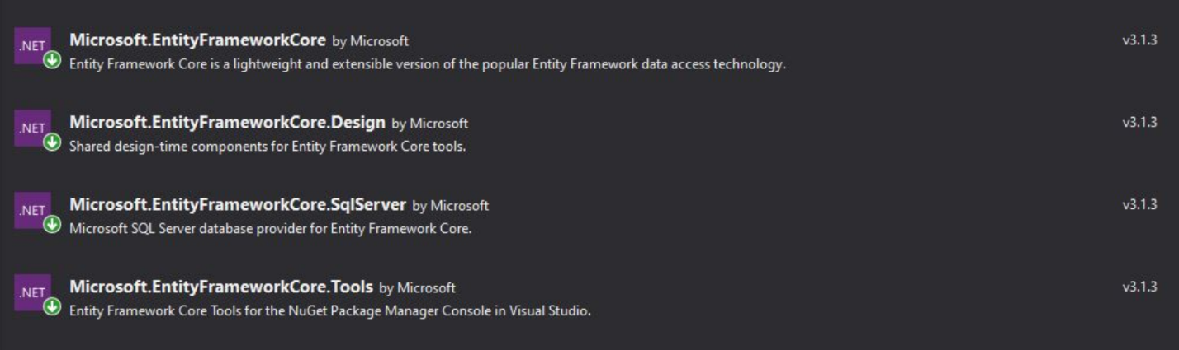

1. Tools > NuGet Package Manager > Package Manager Console
   1. Type “dir” and make sure the contents contain the program.cs and the startup.cs files
   2. If they don’t, change directories: “cd <your folder/project name>” to get to the folder containing the startup.cs and program.cs files. Use”dir” to check your current directory again
2. Type “Scaffold-DbContext "Server=DESKTOP-MPP90VK\MSSQLSERVER01;Database=Grab_and_Go;Trusted_Connection=True;" Microsoft.EntityFrameworkCore.SqlServer -OutputDir Models”
   1. The blue and green highlighted sections are going to be your instance of SQL Server, and your Database name
   2. They can be found by going to View > SQL Server Object Explorer, find the server containing your database, right-click the database and select “*properties”* from the dropdown. (Shown Below)

**Note: If the database was not locally created in Visual Studio, You will need to connect to the Server instance that contains your data base. (Small icon “Add SQL Server” in top left of SQL Object Explorer)

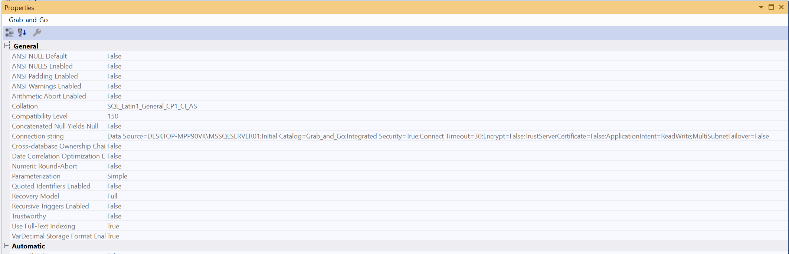

* 1. Copy your blue and green information into the command in step 4 above.

1. You should now have classes pre-populated into your Models folder based on your database along with an additional “yourdatabase”Context.cs class

